***DATA STRUCTURE***

***Project no 02***

**

***Fall 2023***

***Submitted by:***

***Eman Khan***

***Roll No:***

***14644***

***Submitted To:***

***Sir Jamal Ahad***

***Due Date:***

***01-Feb-2025***

***DEPARTMENT OF COMPUTER SCIENCE,***

***ABBOTTABAD UNIVERSITY OF SCIENCE AND TECHNOLOGY (AUST)***

# ***INPUT OF CODE***

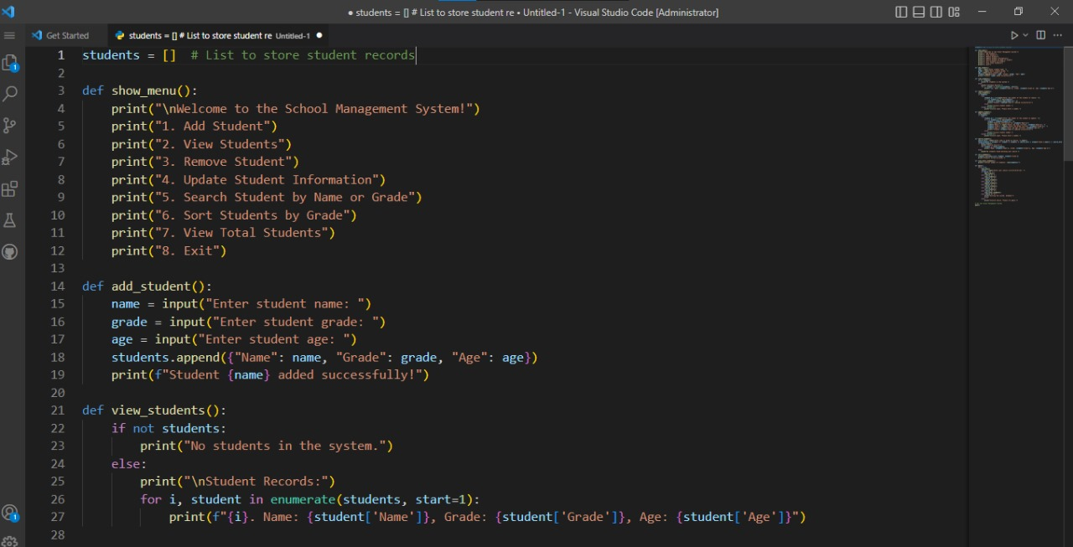

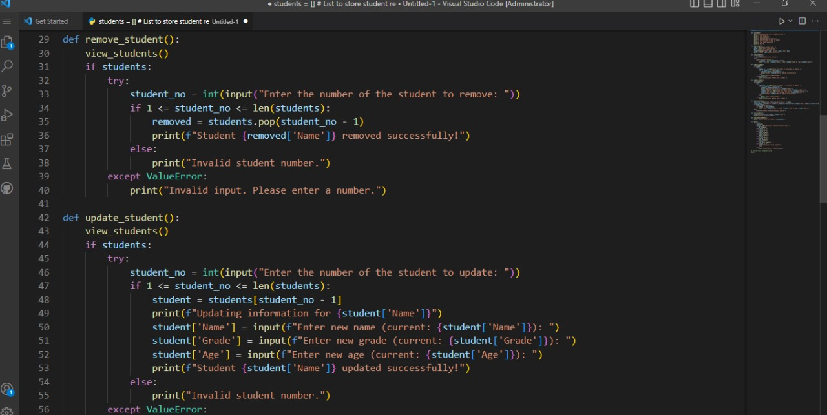

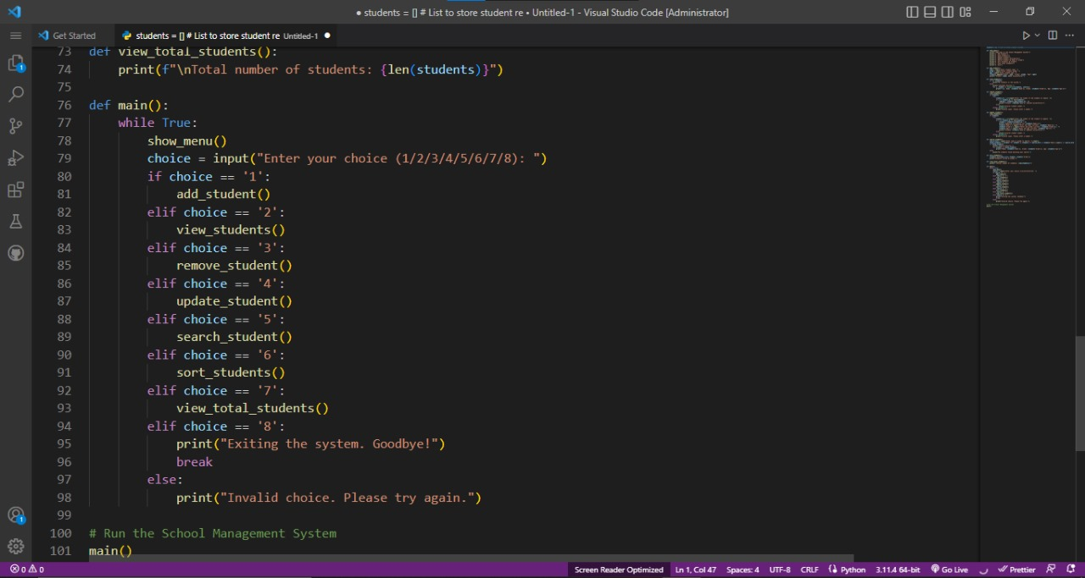

# ***OUTPUT OF CODE***

